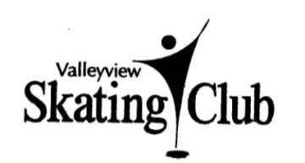
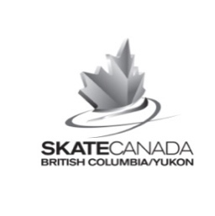
Junior STARSkate
2017 – 2018 REGISTRATION FORM

Name: |  |  |  |  | Female Male
Skate Canada # |  |  |  | Previous Club:
Date of Birth: (month/day/year) |  |  |  |  | Age:
Parents/guardians:
Address: |  |  |  | City: | Postal Code:
Phone: |  |  |  | Cell/alt. phone:
Primary Email: (All updates will be sent to this address)
Emergency Contact:
Phone: |  |  |  | Cell/alt. phone:
Junior STARSkate is a group lesson program designed to make the transition from CanSkate to Figure Skating lessons easier. It is designed to continue the CanSkate skill set and assist in the transition to Figure Skating by completing CanSkate Skills and adding figure skating components. It is a Skate Canada mandated minimum two (2) day per week program. Enrollment is by Coaches’ invitation or audition. If your skater is not able to attend at least 2 days per week, talk to your coach about alternate arrangements.
Fees (Sept – Mar) | Choose your days |  | Your full year fees, Sept 25–Mar 15, include:  - regular season ice costs  - 45 minutes of small group lessons per session  - all Junior STARSkate Ice Fit sessions (see schedule at www.vvsc.ca for times and days)  #Wednesdays are at Sandman Centre. All cancellations can be made up on another day. Check the web site for dates.
Two days: $650  Three days: $925  Four Days: $1100  *(Plus the $50 VVSC Membership Fee.) | Monday 3:30-4:15:  Tuesday 3:30-4:15:  #Wednesday 6:00-6:45: Thursday3:30-4:15:
Session Fees: (may be divided up into equal payments with cheques postdated Sept. 25, Nov. 01, Dec. 01, Jan. 01 and Feb. 01. Your first payment must include the $50 non-refundable membership fee. |  |  |  |  |  | $
*VVSC Membership Fee: The non-refundable VVSC Membership Fee is paid only once in a skating year which runs from Sept 01 to Aug 31 and Includes the $32 Skate Canada fee, $3 Skate Canada Safe Sport Fee and $0.65 insurance fee. |  |  |  |  |  | +$ 50.00
Please note: Waiver must be signed and Fees paid prior to skating on any session. TOTAL PAID |  |  |  |  |  | $
Volunteering: Please support your club and help keep your costs low by volunteering. Every little bit helps
Payment options: CHEQUE (payable to VVSC) ; CASH (full payment only) ; ONLINE ; ($40 will be charged for NSF cheques.)

Waiver and Consent
Skater’s Name:
1) All skaters skate at their own risk. The Valleyview Skating club will not be held responsible for injuries or loss of property incurred while attending this club. The undersigned agrees to abide by the rules and policies of the club, which can be viewed on our web site – www.vvsc.ca and be responsible for the payment of any sessions or lessons booked.
2) I hereby give my consent to the Valleyview Skating Club to put my telephone number and/or email address on a club contact list for the sole purpose of club communications.
3) Should the opportunity arise, I give permission for the above named skater to be included in photos and/or videos which may be taken by representatives of Valleyview Skating Club for publications, media coverage, club website or promotional activities.
Signed |  |  | Date

Do not write below
Payment received by: | Date:
Skate Canada entry: | Receipt:

2017 Aug 20

